Texas Association of Student Councils and Texas Association of Secondary School Principals
Advanced Leadership Workshop 2021
Continuing Professional Education (CPE)
PLEASE KEEP a Copy of THIS FORM FOR YOUR RECORDS.
(TEA no longer requires that the Association retain a copy for verification of attendance.)

Name: School District:

School Name: City:

DATE | Session | Presenter | Length of Session
2/12/21 | General Session | Carlos Ojeda | 30 minutes
2/12/21 | General Session | Chris Collins | 30 minutes
2/12/21 | Advisors Session | Carlos Ojeda | 30 minutes
2/12/21 | Spoken Word Session | Natasha Carrizosa | 45 minutes
2/13/21 | General Session | Zach Gowen | 1 hour
2/13/21 | Advisor Session | Carlos Ojeda | 2 hours
1/23/21 | General Session | Lamar Womble | 30 minutes
1/23/21 | General Session | Carlos Ojeda | 30 minutes
 | Advisors may choose to spent optional time observing student sessions.
 |  |  | TOTAL:
It is the responsibility of the attendee to keep an accurate account of CPE credit hours earned and to give a copy of that documentation to an Association representative at the event as well as to his/her School District. Please keep this copy for your records.

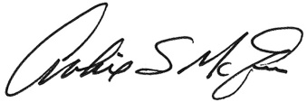
SBEC Provider Number for TASSP/TASC/TAFE: 500-111
Texas Association of Student Councils
1833 South IH-35, Austin TX 78741
Archie E. McAfee, TASSP Executive Director Participant Signature Date Total Hrs.

