Student Leadership Store - Order Online
TASC GRADUATION CORDS: $5 each plus shipping  | Order cords online » |  | TASC PATCHES: $5.00 each plus shipping  | Order patches online »
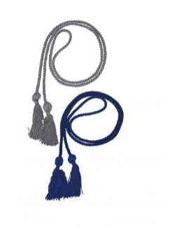  The deadline to order TASC Cords for May graduations is April 30 (shipping). If you are unsure which color cord (silver or blue) check with your school's graduation coordinator. |  | 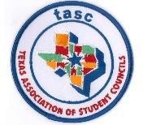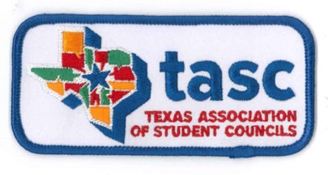
TASC STICKERS: $1.00 each plus shipping | Order stickers/seals online »
TX StuCo Vibes…2 inch | Be Kind… 2 inch |  | TASC 3x1 inch
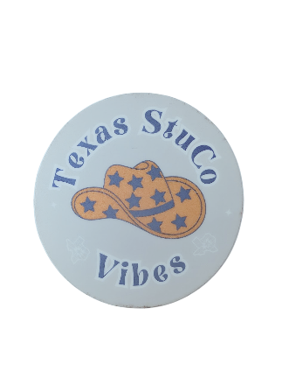 | 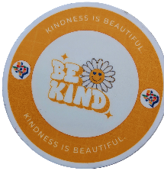 |  | 
NOBODY 2 inch | I TX 2 inch |  | STUCO LIFE 2 inch
 |  |  | 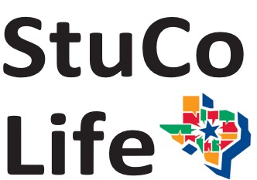
TASC ROUND 2 inch | OUTSTANDING 3 inch |  | SWEEPSTAKES 3 inch
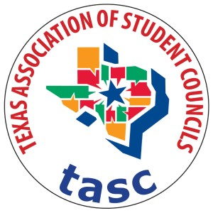 | 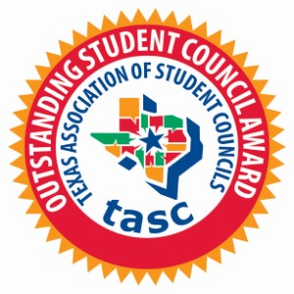 |  | 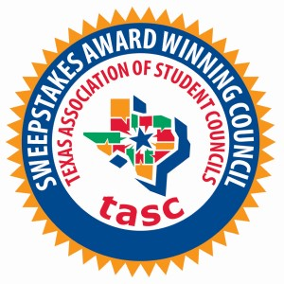
Stay Cool 2 inch | Warning: Driver may be too …2 inch |  | Youre better than you think…2inch
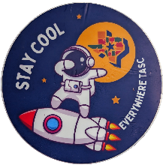 | 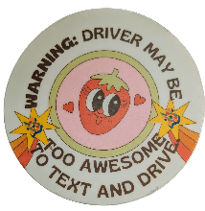 |  | 
TASC PINS: $5.00 each plus shipping |  |  | TASC GOLD SEALS: 50 cents each 1.5 inch
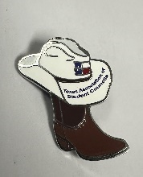 | 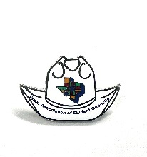 |  | 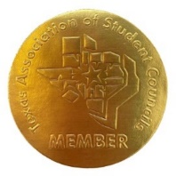
TASC PINS: $3.00 each plus shipping | Order pins online »
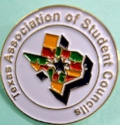 | 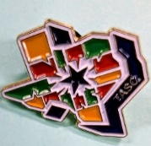
UD: 7/23
Student Leadership Book Store
Item# | Book Title | Qty left in stock | cost per
1 | 50 Ways to Use Your Noodle | 11 | $ 20.00
3 | Affordable Portables | 21 | $ 25.00
4 | Big Book of Conflict Resolution Games | 7 | $ 26.00
5 | Check Model for Event Planning | 9 | $ 19.00
6 | Everyday Leadership: Attitudes & Actions for Respect & Success | 10 | $ 13.00
8 | Global Games | 11 | $ 23.00
9 | Igniting Your Leadership | 4 | $ 15.00
10 | Journey Toward the Caring Classroom | 4 | $ 30.00
11 | Jump Start Vol. 1: Leading Yourself | 4 | $ 12.00
12 | Leadership Lessons 3 (only left in stock) | 6 | $ 16.00
13 | Leadership Lessons: ….to Lead By | 8 | $ 15.00
14 | Leadership Lessons: More … | 4 | $ 15.00
15 | Open to Outcome 1st edition | 5 | $ 6.00
16a | Open to Outcome 2nd edition | 12 | $ 17.00
17 | Portable Team Building Games | 1 | $ 25.00
18 | Raccoon Circles | 2 | $ 35.00
20 | Springboard | 7 | $ 20.00
22 | Together is Better | 3 | $ 20.00

