TASC Plans re Annual Conference & COVID
As always, TASC’s first priority is the well-being of its members.

- Positive test for COVID
  - Schools may substitute another student of the same gender.
  - The delegation may substitute another adult (school employee or parent approved by the school) for the advisor.
- Positive test immediately following the conference
  - Should an attendee test positive for COVID within 3-4 days following the conference, TASC requests that you notify TASC (terry@tassp.org). TASC will inform attendees that a positive test was reported. No names will be shared.
- Refunds
  - If a registered delegate’s school institutes a no travel policy, conference registration for the school group will be refunded upon receipt of a copy of the school’s policy, superintendent’s statement, etc. Advisors must contact Lori DeLeon (lori@tassp.org) in writing prior to the workshop regarding the need for a refund.
- Masking
  - Masking is strongly encouraged for all participants when not actively eating, drinking, or outdoors. All individuals who are not vaccinated must mask when not eating or drinking.
  - Advisors are responsible for ensuring students follow these guidelines.
- Other
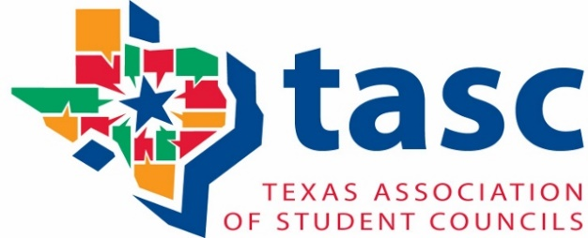
  - Hand sanitizer will be available, and its use is recommended.

